**Flow chart**

Welcome Message

User interface

1. List Current Files

IS Select Option ?

2. Business Operations

3. Close Application

yes

2.Business Operations

3.Close Application

1.List Current Files

yes 1. Add a File

2. Delete a File

3.Search for File

Add a File

Delete a File

Search for File

**Git Hub URL**

https://github.com/Graceybbez/Project1_BusinessOperation.git

Spring planning

2 week sprint

10 man days’ work

**Output Screen shot:**

Welcome screen and it’s options

1. List Current Files

2. Business Operations

3. Close Application

**1. List Current Files**

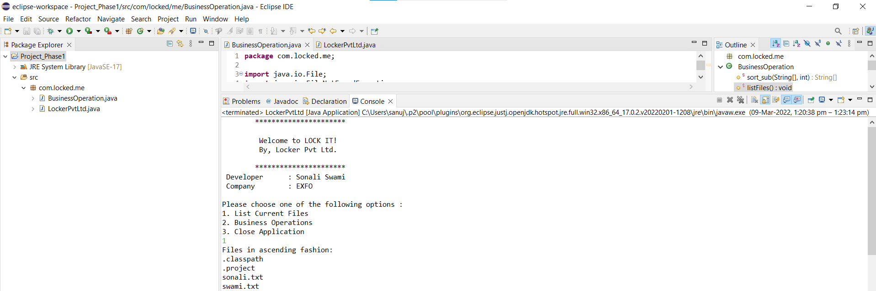

**2. Business Operations**

1. Add a File

2. Delete a File

3. Search for a File

**1. Add a File**

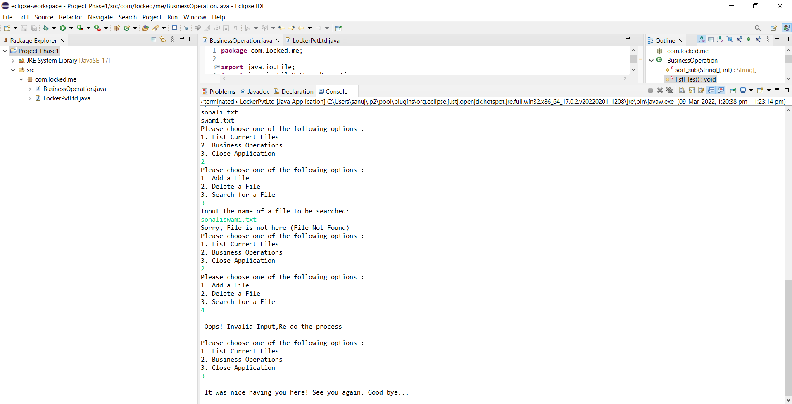

**2. Delete a File**

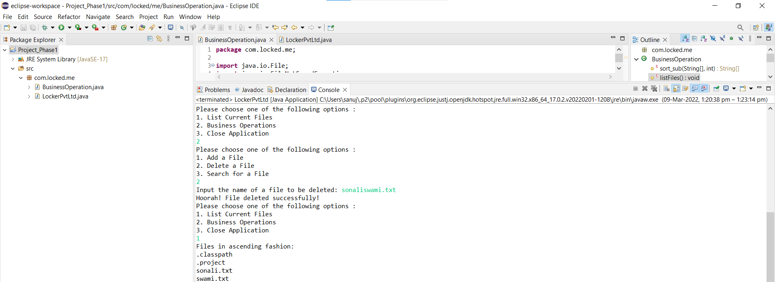

**3. Search for a File**

